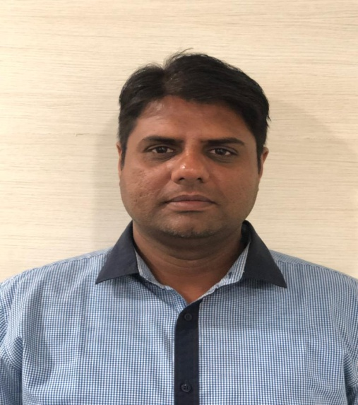

FULL STACK DEVELOPER

**Raman Hira**

**WORK EXPERIENCE: 14+ YEARS**

*September 2022 to Present*

**CES**

* Working on technologies like JavaScript, ES6, React, Redux, Node, SASS, HTML, CSS, MongoDB,, Git and Microsoft Azure
* Working on core responsibilities like analyzing and understanding requirements, produce high quality of code in development.
* Working with Helena in India as a Lead Full Stack Developer.

*September 2013 to September 2022*

**Tata Consultancy Services (TCS)**

* Working on technologies like JavaScript, ES6, React, Redux, Node, SASS, HTML, CSS, Postgre SQL, Git and Microsoft Azure
* Working on core responsibilities like analyzing and understanding requirements, produce high quality of code in development , unit testing and deployment
* Worked with Ericsson (Automation and AI Marketplace) in India as a Senior Full Stack Developer.
* Worked with Cisco (DNAC) in India as a Senior Front end developer.
* Worked with BASF (Xarvio) in Germany as a Senior Front end developer
* Worked with Fidelity (AWS & EI) in India as a Front end developer

*April 2011 to July 2013*

**Infosys**

* Worked in front end related technologies like HTML, CSS, JS, React, Node, AJAX and SVN
* Worked with Dansk (ecommerce) in India as a Front end Developer.
* Worked with American Express (India Gift Card) in India as a Front end developer

*October 2010 to March 2011*

**Sapient**

* Worked in front end related technologies like HTML, CSS, JavaScript, JQuery and AJAX
* Worked on core responsibilities like analyzing and understanding requirements, produce high quality of code in development with unit testing.
* Worked with BMO from India as an Interactive developer

*May 2010 to September 2010*

**Miri Infotech**

* Worked in front end related technologies like HTML, CSS, JavaScript and AJAX
* Worked on core responsibilities like analyzing and understanding requirements, produce high quality of code in development with unit testing.
* Worked with Hobsons in India as a Software Engineer

*August 2008 to May 2010*

**OATI**

* Worked in front end related technologies like HTML, CSS, JavaScript and AJAX
* Worked on core responsibilities like analyzing and understanding requirements, produce high quality of code in development with unit testing.
* Worked with Web-GUI team from India as a Software Developer

**SKILLS**

JavaScript, ES6, React, Redux, Node, Express, HTML, CSS, Bootstrap, SASS, Postgresql, MongoDB, MERN, JEST, Postman,Git, JIRA, Azure, Azure DevOps, AWS, S3, CloudFront

**CONTACT**

391-mail4.png

ramanhira@gmail.com

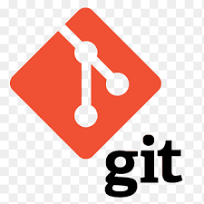001-home.png067-phone.png

+91 9540146677

Jalandhar, Punjab, India

https://github.com/ramanhira10

https://www.linkedin.com/in/raman-hira-533b9a25/

**HOBBIES**



Workout



Yoga

006-pencil.png018-music.png

Soft Music

Play Chess

**EDUCATION**

* Bachelor of Technology in Information Technology.
* Diploma in Information Technology.